Safety aspects of ultrasound in prenatal diagnosis
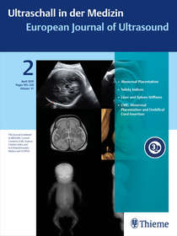
Kai-Sven Heling, Peter Kozlowski
Publication Date :
Issue No 2 _07 April 2020 (online)
© Georg Thieme Verlag KG
Stuttgart · New York

Ultrasound was used for the first time in pregnancy in the 1960 s and then found broader clinical application in the 70 s and particularly in the 80 s, thereby revolutionizing obstetrics and ultimately resulting in the development of a new subspecialty: prenatal diagnosis and perinatal medicine. This means that ultrasound has been used for more than 40 years in pregnancy to examine fetuses. This development was facilitated on the one hand by the ease of use of the method and the resulting broad availability and on the other hand by the fact that ultrasound is an imaging method that does not require the use of physical radiation. This resulted in early differentiation from diagnostic radiology (classic abdominal X-ray, pelvic X-ray, amniofetography) and later also from computed tomography. Magnetic resonance imaging (MRI) has the potential to supplement ultrasound for targeted issues but is still very cost-intensive and has numerous limitations.

Artificial Intelligence: What Is It and How Can It Expand the Ultrasound Potential in the Future?
Vito Cantisani,Giorgio Grani, Francesco Tovoli, Fabio Piscaglia, Carlo Catalano
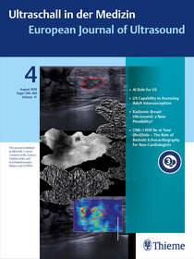
Publication Date:
Issue No 4_04 August 2020 (online)
© Georg Thieme Verlag KG
Stuttgart · New York

During the past century, our ability to perform complex calculations massively increased, due to the availability of powerful processors, and diffuse, ubiquitious presence of personal computers for home and professional applications. Many physicians are worried by the application of Artificial Intelligence (AI) in medicine, envisioning an Asimov science-fiction scenario. But is this real? What the AI use in medicine and, particularly, ultrasonography actually entails?

